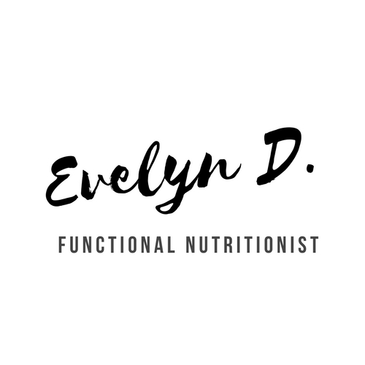 IF PLAN & MEAL OPTIONS

Name: ________________________________________________ Date: ________________________

Target Fasting Ratio (i.e., 16:8, 20:4,etc): ____________________________________________________

Time of Last Meal (Fasting Start): ________________ (Water, Coffee, Tea, Seltzer Only with Electrolytes/Sea salt)

Break-Fast Time: ______________________________________________________________________

Meal 1 Options:

Meal 2 and/or Snack Options (as needed):

NOTES: